# Proposal for Revamping Pala Kojwang’ Primary School

Prepared by:

Dorothy Adhiambo

24/9/2024

To:

Board of Governors,

Pala Kojwang Primary School

## Executive Summary

This proposal outlines a comprehensive strategy to revamp Pala Kojwang’ Primary School, established in 2006 under the "Kawa Self Help Group." Despite its consistent academic success, the school has faced numerous challenges, including poor infrastructure, low staff salaries, lack of digital presence, and security concerns. The proposal seeks to modernize the school, address these challenges, and position it for long-term growth.

Going through twitter, old tweet about our school appear and I begin to wonder which other stories exist out there, which I found out, almost zero. Anyway, this boy’s story of performing well but having challenges getting to school, I can’t help but feel sad that our primary school could not even sponsor his shopping to school, making me believe, after completion, the school kind of cuts ties with the students and parents because after all, the money is in the bag, but then I ask myself, is it? We can do better I believe.

Anyway, combing through the web, there are blogs that just post the schools physical location and address with only one writing something positive about the school. However, I am struck again as there are no pictures. So I wonder, what? In this world now, no social media presence? There is one unofficial Facebook group for alumnus and teachers but has only two followers and its inactive like never posted in before. This made me worried, I mean the blog praises the community oriented school but there is nothing to show for it besides student transcripts? No, my dream has always been to make life better and I learnt that through my parents’ efforts to develop and maintain the school. However, we must all agree that we have gotten to a point where sustainability matters as must as performance. Oh yeah, before I forget, I think Orinde Peter, one of the first successful candidates, is one of the alumnus proud of the school and able to reference it on their professional pages, LinkedIn. I commend that and now I wish more would come out, but I believe charity begins at home and the school has a role to play. I am sorry if it sounds hash but I tend to be critical.

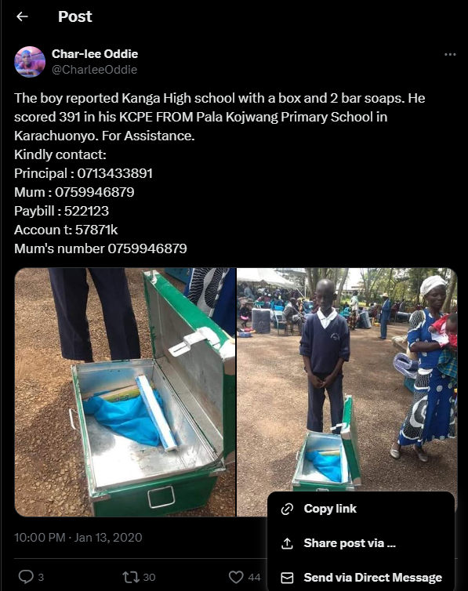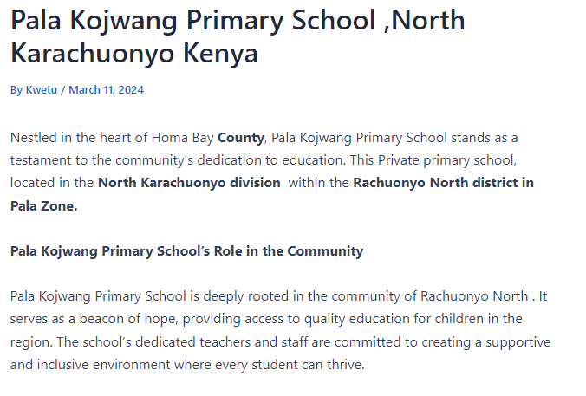

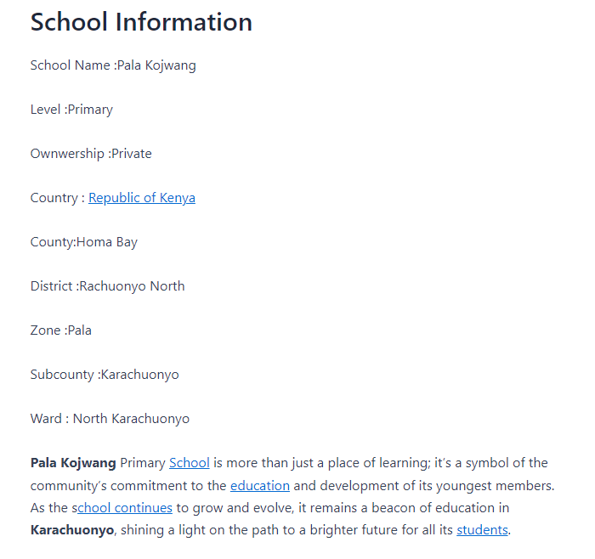

The proposal's main goals include:

1. Digital transformation and branding
2. Infrastructure improvements, including security, library, computer installation, and construction of a dining/meeting hall
3. Staff welfare enhancement
4. Securing financial aid from local and international organizations
5. Strengthening relationships with alumni

## Objectives

### Digital Transformation and Branding

#### Establish Online Presence:

Create an official Gmail account, Facebook page, and website to showcase the school’s achievements. Hire a digital photographer to capture the school’s academic and extracurricular successes for promotion.

#### Alumni Network Development:

Set up a Facebook group to connect alumni, encouraging them to support the school both financially and in mentoring students.

#### Digitize School Systems:

Implement a school management system to improve communication, streamline operations, and keep track of student progress and staff records.

### Infrastructure and Security Improvements

#### Classroom Renovation and New Facilities:

Renovate existing classrooms and construct additional ones as needed, focusing on creating a conducive learning environment.

#### Library Setup:

Build and stock a fully functional library to improve access to learning materials and promote a reading culture among students.

#### Computer Installation:

Install a modern computer lab equipped with internet access, to enhance digital literacy among students and staff.

#### Dining/Meeting/Graduation Hall:

Construct a multi-purpose hall for student dining, meetings, and school events like graduations. This will also serve as a community hub.

#### Security Review and Upgrades:

Conduct a comprehensive security review to ensure the safety of students and staff. Implement necessary upgrades such as installing perimeter fencing, lighting, and employing security personnel.

### Teacher Welfare and Support

#### Salary Review:

Assess current salary scales and develop a phased plan to increase salaries in line with performance and budget improvements.

#### Professional Development:

Provide teachers with training opportunities to enhance their skills in modern teaching methods and technology.

### Financial Restructuring and Fundraising

#### Financial Management Overhaul:

Engage a financial consultant to identify inefficiencies and introduce transparent financial practices.

#### Fundraising from NGOs and Abroad:

Actively seek partnerships with local and international donors, NGOs, and philanthropic organizations. Highlight the school's roots in the "Kawa Self Help Group" to strengthen its appeal to community-based project funders.

## Justification

The challenges at Pala Kojwang’ Primary School, including underfunding and lack of infrastructure, have hindered its growth and the wellbeing of students and staff. Despite these limitations, the school has consistently produced strong academic results, such as a student scoring 391 marks in the 2020 KCPE who later joined Kanga High School. The school needs a significant boost in its facilities, security, and digital presence to match its academic success.

## Timeline and Next Steps

### Year 1-2: Establish Digital Presence, Security Review, and Alumni Network

Create social media accounts and official email.

Hire a professional photographer to document the school.

Conduct a security audit and begin upgrading fencing, lighting, and personnel.

### Year 3-5: Infrastructure and Financial Management Overhaul

Renovate classrooms and construct new facilities, including the library, computer lab, and hall.

Digitize school administrative systems.

Ensure transparent financial management practices.

### Year 5-10: Strategic Growth and Academic Excellence

Strengthen partnerships with alumni and international donors.

Focus on improving academic performance and overall public perception.

**NB: This timeline is just an approximate but it is quite flexible, more dynamic than static.**

## Conclusion

This proposal represents a comprehensive plan to modernize and secure the future of Pala Kojwang’ Primary School. By focusing on digital transformation, security, infrastructure, and financial transparency, we aim to create a better learning environment and a more efficient, well-regarded institution.

With your approval, we are ready to begin this transformation and ensure that Pala Kojwang’ becomes a leading school in the region for both academic achievement and student welfare.

Signatories:

Dorothy Adhiambo

Elidah Ayiemba

[Names of Supporters]